**PRESS RELEASE**

**COMMUNICATIONS AND MEDIA TEAM OF THE 2023 ASEAN SUMMIT**

**No.49/SP/TKM-ASEAN2023/ENG/5/2023**

**Indonesia Reiterates Call for Cessation of Violence in Myanmar**

**West Manggarai, 8 May 2023** **–** Indonesia reiterated the call for an immediate cessation of violence in Myanmar. According to President Joko “Jokowi” Widodo, the current situation in that country does not make any party a winner as it only makes the people suffer.

“People will become victims because this condition will not make any party a winner. I invite all of us to come together and create a space for dialogue to find solutions together,” said President Jokowi in a press conference at the Meruorah Hotel, West Manggarai Regency, East Nusa Tenggara Province, on Monday (8 May).

Therefore, the President affirmed that Indonesia’s chairmanship in ASEAN this year will continue to push for the implementation of the “Five-Point Consensus”. One of the points in the consensus is related to humanitarian assistance.

President Jokowi said that Indonesia has made various efforts to provide humanitarian assistance and through its chairmanship in ASEAN, Indonesia was able to facilitate the ASEAN Coordinating Centre for Humanitarian Assistance on Disaster Management (AHA Centre).

After a long delay due to access issues, the President said that the joint needs assessment has been completed.

“The issue was access. Yesterday, the AHA Centre accompanied by the ASEAN monitoring team was on their way to deliver humanitarian assistance. Unfortunately, a shootout broke out along the way,” said the Head of State.

Previously, Minister of Foreign Affairs Retno Marsudi had also explained that there are two stages of humanitarian assistance to Myanmar.

The first stage is related to lifesaving aid which has been completed because it is related to COVID-19 relief assistance. The second stage is life-sustaining assistance.

“The second stage faced obstacles due to a lack of access for the AHA Centre to reach the people in need, especially in areas outside the control of the Myanmar military,” said Retno. (Setpres/TR/Elvira/WW/PPR)

***

For more information, please contact:

**Director General of Public Information and Communications of the Ministry of Communications and Informatics – Usman Kansong (0816785320).**

Get more information at <http://asean2023.id>, <https://infopublik.id/kategori/asean-2023>, and <https://indonesia.go.id/kategori/ragam-asean-2023>

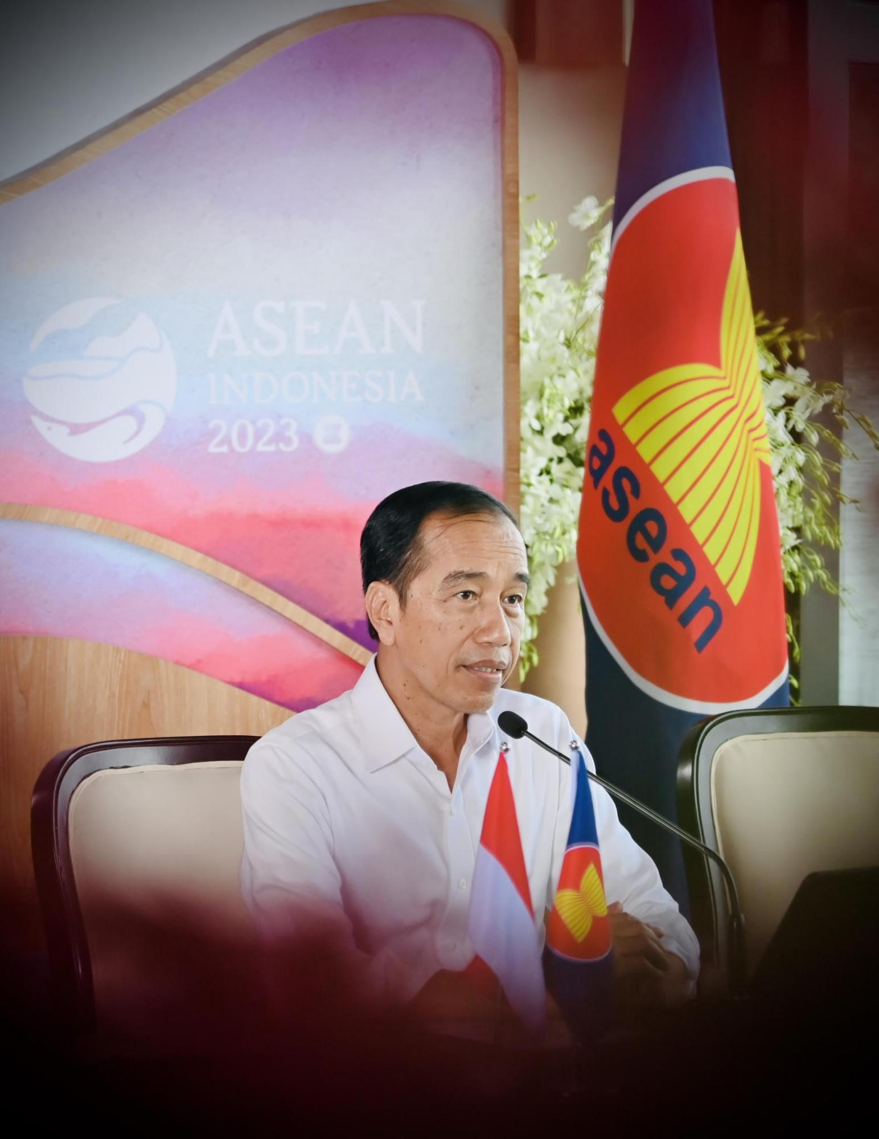

President Joko “Jokowi” Widodo speaks in a press conference at the Meruorah Hotel in West Manggarai Regency, East Nusa Tenggara Province on Monday (8 May). President Jokowi reiterated the call for an immediate cessation of violence in Myanmar. The Head of State said that the current situation in Myanmar does not make any party a winner as it only makes the people suffer. Photo: BPMI